**REQUEST LETTER**

**1. Dear Sir/Madam,** (or name if given)

**2. The purpose of the letter: explanation, reason for writing (1-2 sentences what kind of information you are interested in)**

* + **I am writing to ask for** information about membership in the Snap Fitness Sports club. **Please let me elaborate the situation.**
  + I am writing to ask for complete itinerary of a trip to Africa that I booked with your company. Please allow me to elaborate
  + **I am writing in response to ...** / I was interested in your advertisement in ...
  + **I am writing to inquire about ...**

**3. Explanation in more detail: who you are, exactly what information you need, why, when and in what form you need it (letter, fax, email)**

* + **Who am I? I am Pinky, from the Accounting Department, currently working in …**
  + I have read your advertisement of the … and would like to get more information
  + **Explain why**
  + The reason why I … is that, firstly …. Secondly, …., What’s more, …
  + **Give details**
  + (To explain) in a little more detail,
  + **Why? When?**
  + **I would appreciate (it) if you could** inform me asap (as soon as possible)
  + I would like to receive it asap but not later than a week before flight
  + **In what form?**
  + **You could send the above-mentioned information to** my e-mail or a fax
  + **It would be of great help if you could fax me the details**
  + You can contact me on my mobile phone number which is: 0454 ...

**4. Formal ending, name, signature**

* + I look forward to hearing from you!
  + **I look forward to receiving a prompt reply!**
  + Yours sincerely, ... (you know the name of person you are writing to)
  + Yours faithfully, ... (you don't know the name!)

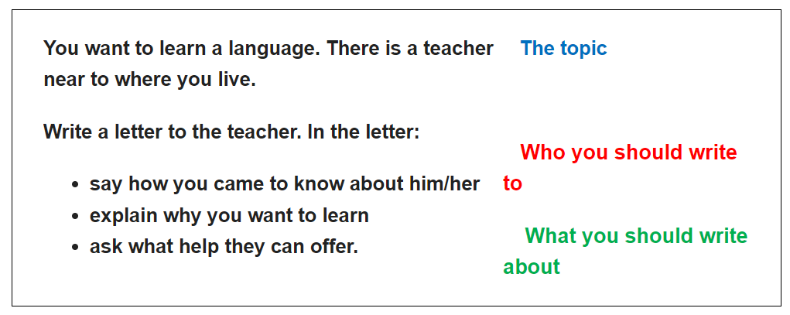

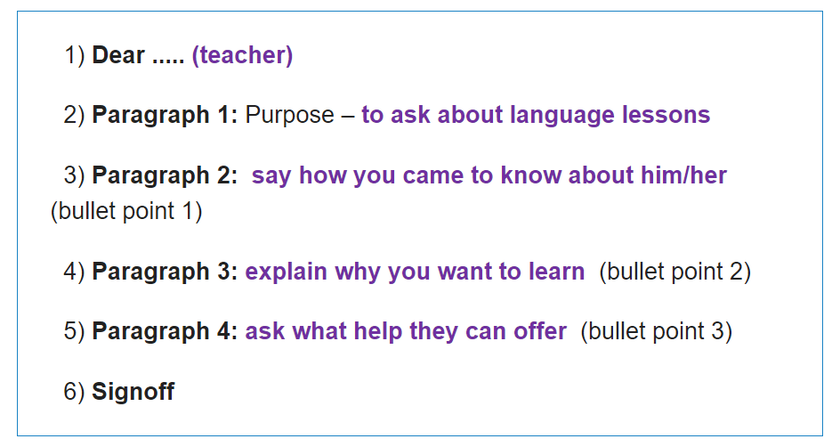

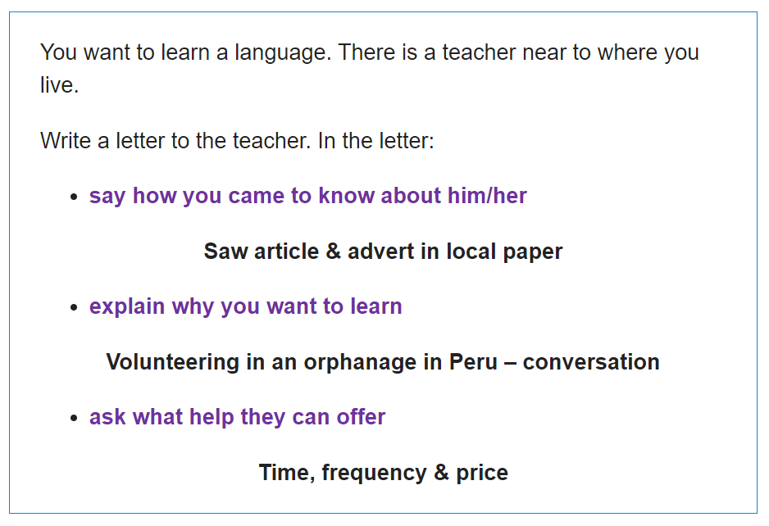

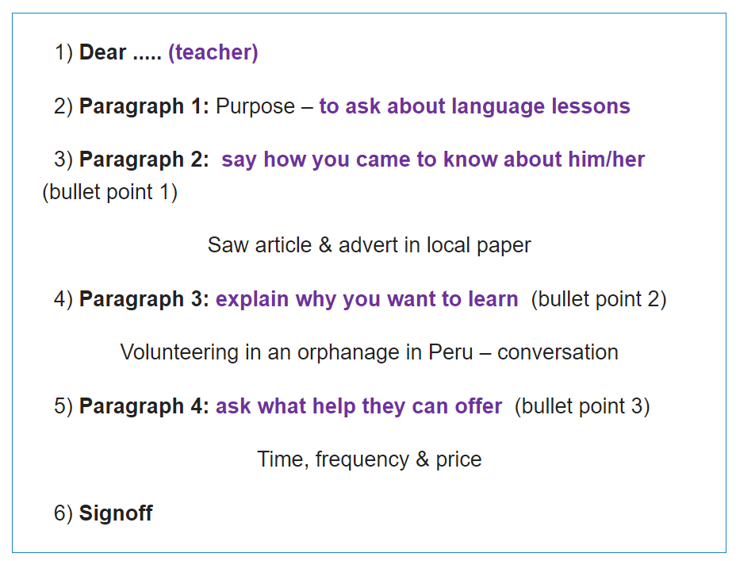

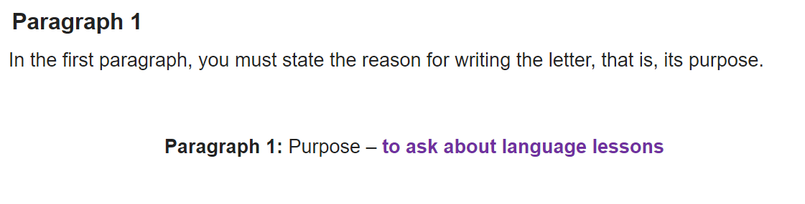

* + **I am writing to ask for** information about membership in the Snap Fitness Sports club. **Please let me elaborate the situation.**
  + I am writing to ask for complete itinerary of a trip to Africa that I booked with your company. **Please allow me to elaborate.**
  + **I am writing to inquire about ...**

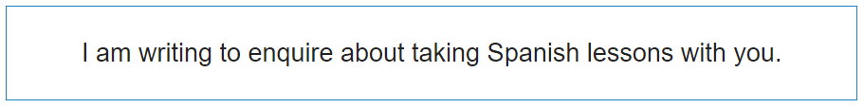

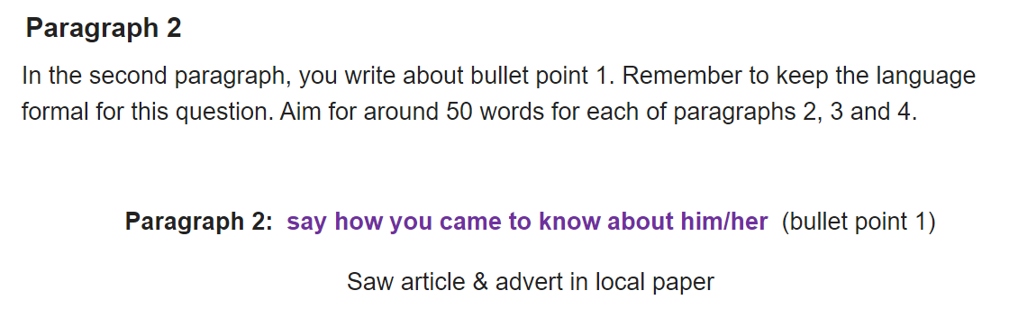

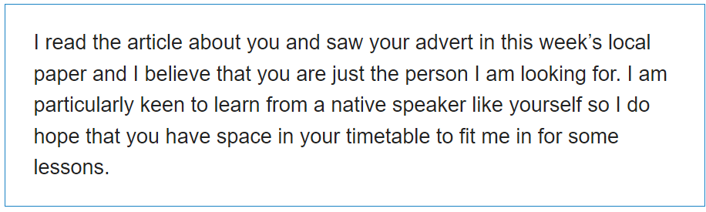

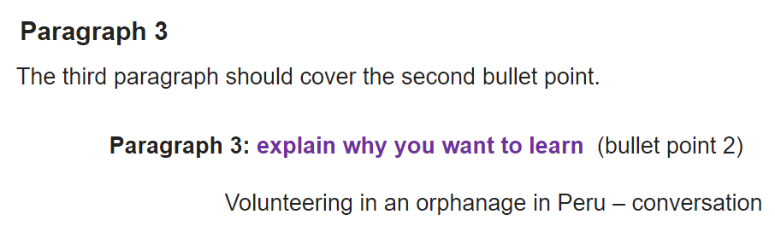

**The reason why I love learning language is that ….**

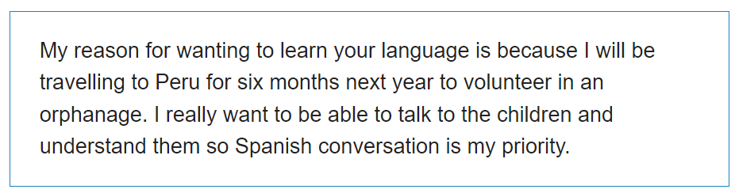

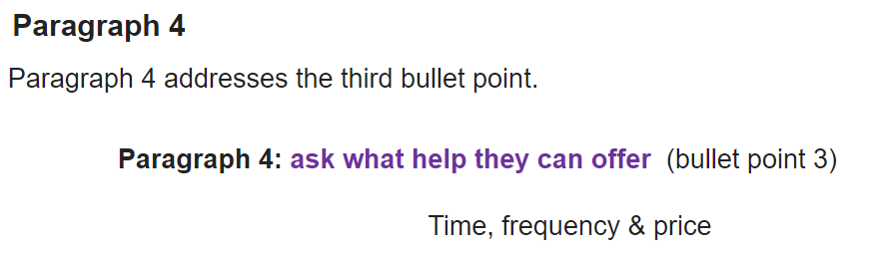

* + **I would be grateful** **whether you could tell me** what the price is.
  + **I would be interested to know if I** will get a certificate
  + **I wonder if you could possibly tell/send me the time I can study in your class**
  + **I would appreciate (it) if you could inform me of ….**

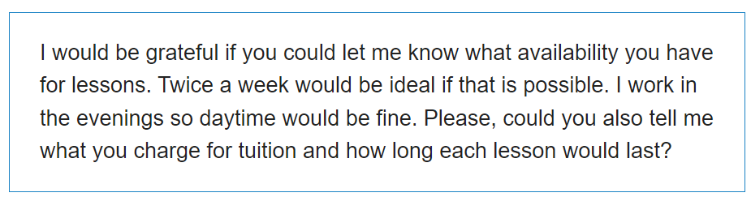

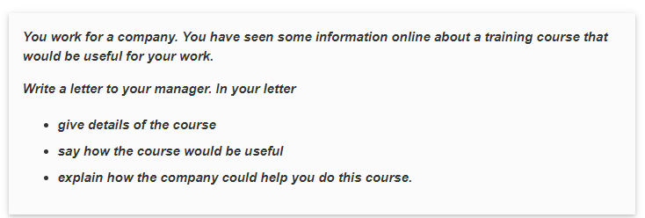

Dear Martin,

I have recently become aware of a course called Social Media Marketing Essentials and **I am writing to ask for your support in taking this course.** Please let me elaborate exactly on my situation.

**To explain in a little more detail,** it is a five-day intensive program being offered by the Business Leadership Association and it starts on Monday 15 February. I believe the course would **be of great benefit to** our company as we have been recently considering how to **build up** our social media presence and **attract more customers online**. The reason why I would like to take up the course is that I think this Social Media course will help me **professionally** in my capacity as Communications Manager and **make a real difference to our company**.

For these reasons, **I would be grateful** **whether you could offer me paid leave from 15-20 February to attend the course**. **It would be helpful if** other team members did not **take leave** at this time; so far nobody else has applied. I believe this will not be a particularly busy time at work, but *I am prepared to spend some time working on those evenings if needed*.

I look forward to hearing from you soon.

Yours sincerely,

Neil MacFarlane

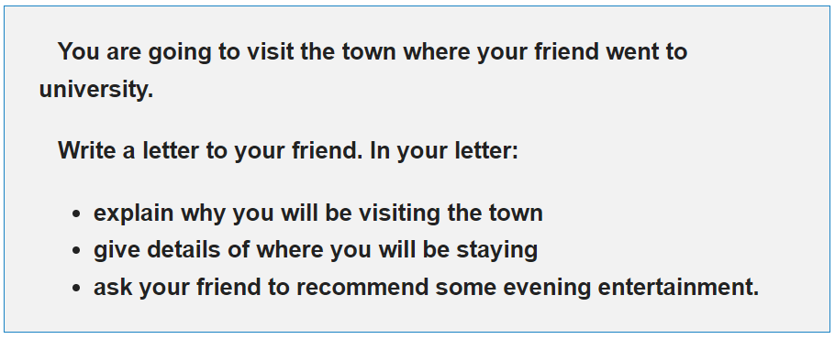

**Dear Ms Hà,**

**I am writing to inquire about**….. **Please let me elaborate the situation.**

The reasons why I … are that, firstly …. Secondly, …., What’s more, … **…**

**I would be grateful** **whether you could tell me** …. **I would be interested to know if I** …

**I look forward to receiving a prompt reply!**

With love,

**…**